Micro-Economic Analysis of Chiquita

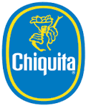

Module: Business and Financial Environment

Lecturer: Mr Jim Power

Group: B3

Date of Submission: 13/11/2014

Student Names:

David Gahan 09549102,

Adam Copeland 11414212,

Jane Lawrence 14200448,

Chang Zheng, 14203321

Prachi Jain, 14202575

Tafadzwa Nyandoroh 14203185

Table of Contents

Introduction.................................................................................................................................2

Company Background..................................................................................................................2

Micro-Economic Analysis.............................................................................................................5

Demand and Supply Analysis.......................................................................................................6

Market Analysis...........................................................................................................................8

Strategic Operations...................................................................................................................10

Opportunities..............................................................................................................................12

Challenges...................................................................................................................................13

Conclusion...................................................................................................................................14

Reference List..............................................................................................................................15

**Introduction**

The banana is the world’s most traded fruit and is a multi-billion dollar industry. This paper will take an in-depth look at Chiquita Brands International Inc. who is the leading firm in the competitive banana market, with annual revenues of more than $3 billion (Chiquita, 2014). This article will provide a brief outline of Chiquita’s background and its performance in the face of The Great Recession. It will then discuss the market in which it operates, from a micro-economical perspective. This paper will highlight future challenges and opportunities facing Chiquita and present a plan as to how the company will cope with these market conditions in the future.

**Company Background**

Chiquita is a leading banana producer that grows, procures, markets and sells bananas and other fresh fruits and vegetables under the Chiquita name. Bananas account for about 65% of Chiquita's sales. It also offers salads and healthy snacks but this paper will be focusing on its main product, bananas.

During the recession of 2007, Chiquita struggled to maintain a solid competitive performance due to poor management decisions and increased commodity prices. As a result of this, stock dropped by 10% and they have missed earning targets by up to 88% (Forbes, 2013).

Chiquita have recently been bought by Cutrale-Safra. This has positively impacted on Chiquita’s share price, which has increased by over 40% since August (Reteurs, 2014). Cultrale now faces the challenge of repairing damages sustained during the recession, such as volatile operating conditions and slim margins.

As there are only a few dominant companies in the global banana market, it is classified as an oligopolistic market. These companies are usually vertically integrated; they own or contract plantations, sea transport, ripening facilities and distribution networks. Because of this structure, it gives them considerable market power and cost advantages due to their scale.

The world's five largest producers and marketers of fresh bananas are Chiquita Brands International, Del Monte Fresh Produce, Dole Food Company, Fyffes and Noboa respectively. These companies own banana plantations in most of the banana-producing regions in the world (Evans and Ballen, 2009).

With regards to the banana industry, Chiquita has the leading market share of 13% (See Figure 1.1 below). The other major producers in the banana market are; Dole with 11% market share, Fresh del Monte with a 12%, Fyffes with 6% and Noboa with 2%. In 2013, the market share of the top five companies was 44.4%, down from 70% in 2002. As a consequence, other companies, such as, discount brands now account for over half of all exports. ‘Others’ represent this shift in the market share at 56% (Bananalink, 2013).

Figure 1.1

(FAO, 2014)

Looking at the market, North America accounts for about 58% of Chiquita's business while Europe accounts for nearly 31% (Chiquita, 2013). Retail supermarkets and the hospitality industry account for the majority of sales in these regions. Both continents have faced challenging market conditions in the last 5 years. America’s net household wealth fell by 35% over 7 years during the recession and European households spent, on average, about 3% less of their total income on food during the years of 2007-2010 (FoodDrink Europe, 2014). Fortunately, as bananas are a necessity food, this product didn’t suffer to the extent of other luxury food items. Both economies are now improving, with America’s GDP reaching $16.8 trillion (a four-year high) and Europe’s climbing to $16.58 trillion from a slump of $16.3 trillion in 2010 ([Data.worldbank.org](http://data.worldbank.org/" \t "_blank), 2014).

As shown in Figure 1.2, Chiquita banana farms are located in South America and North America and are mostly concentrated in fertile soil regions of Mexico, Guatemala, Honduras, Nicaragua, Panama, Colombia and Ecuador (Chiquita Bananas, 2014). Contracted farmers then separate, wash and box the bananas. The bananas are then distributed around the world on ships and are stored in refrigerators. Once the fruit reaches its destination, it is artificially ripened in warehouses. They are then transferred (usually by road or rail transportation) to retailers and wholesalers.

Figure 1.2

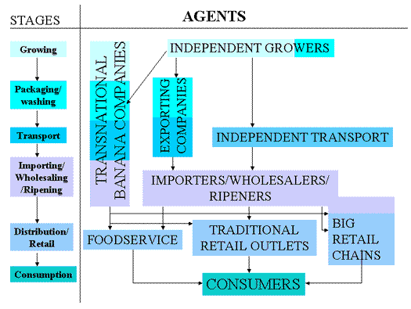

(UNCTAD, 2011)

**Micro-Economic Analysis**

Figure 1.3

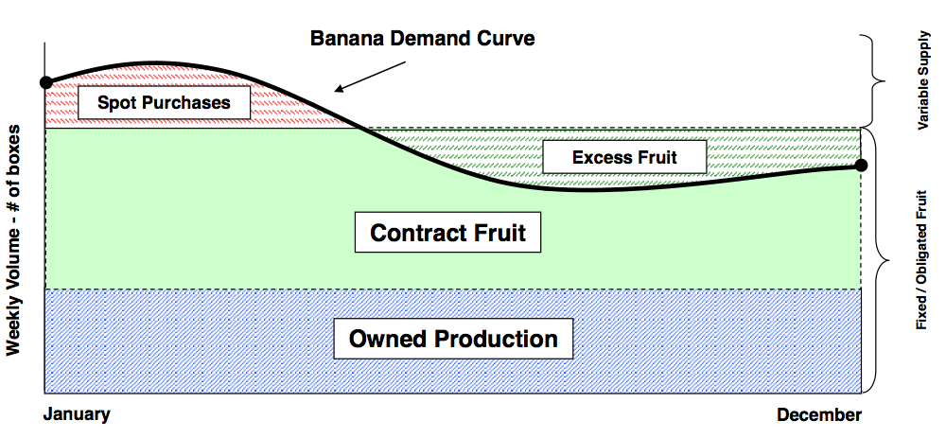

**Chiquita Demand Curve**

**Summer**

**Spring**

As shown in Figure 1.3, demand for Chiquita bananas peak in the first half of the year and supply exceeds demand late in the year. Seasonal fluctuations can be explained by a rise in the demand for bananas in the summer months, thus causing a rise in the price, and the reverse for the winter months. This is not unique to Chiquita, and so we will now analyse the demand and supply trends of the banana industry as a whole.

**Demand and Supply Analysis**

In Figure 1.4 there is a shift outwards in the demand curve causing prices to rise from price A to B. This is caused by the increased demand for bananas in the summer months because of a change in consumer tastes.

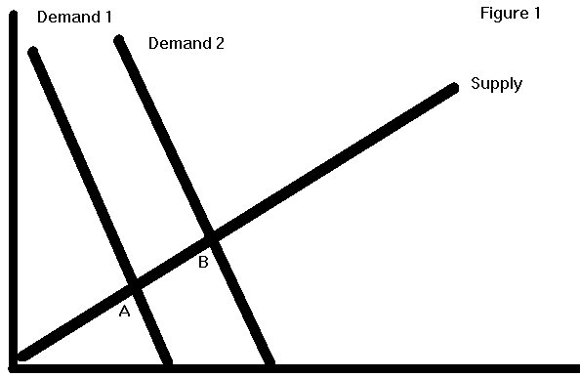

Figure 1.4

(Facweb.furman.edu, 2014)

Most of the bananas are grown in the Southern Hemisphere.  When it is summer in the United States or Europe, banana-producing countries in the southern hemisphere experience difficulty in producing fruit due to cold winter conditions. A decrease in supply occurs during North America’s and Europe’s summer months, causing a rise in prices of bananas.  During autumn/winter demand decreases and supply increases. This is illustrated in Figure 1.5 where the supply curve shifts from 1 to 2 as a result of decreases in winter production. This causes a rise in price from A to B.

Figure 1.5

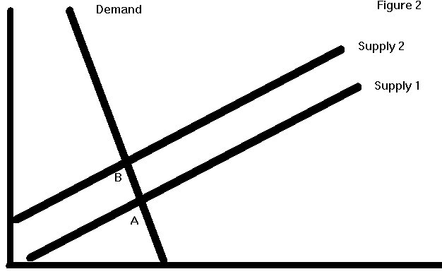  
(Facweb.furman.edu, 2014)

Figure 1.6 illustrates the inelasticity of the demand curve. When supply shifts outwards from Supply 1 to Supply 2, there is an increase in the volume of production of bananas. This will, in turn, lead to a decline in the price of bananas from B to A.

Figure 1.6

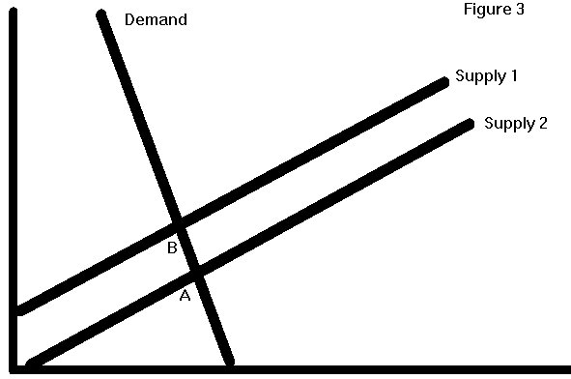

(Facweb.furman.edu, 2014)

In contrast with our analysis of the banana industry as a whole, Chiquita’s supply remains constant throughout the year but demand fluctuates with seasonal changes. These seasonal fluctuations affect demand and supply and because of this, Chiquita experiences pricing deviations during the year. Furthermore, the demand curve for Chiquita bananas is inelastic as they do not have any exact substitutes, they are a necessity as a food and are almost immaterial when compared with a consumer’s overall budget. According to UN statistics the banana is the world’s most popular fruit and it is regarded as a basic dietary requirement (FAO, 2014).

**Market Analysis**

In the past few years the banana market has been undergoing various changes that have influenced market development.

The banana market might develop through mergers between rival firms. As a result of increased competition in the banana market, the market share of major banana producers has been in decline over the past decade. In 2013, the market share of the top five companies was 44.4%, down from 70% in 2002 (Bananalink, 2014). In order to counteract this, firms are identifying mergers or acquisitions as a means of increasing market share. A merger between companies would lead to opportunities to expand into new geographic regions, strengthen their market position and help reduce costs. For example, in March 2014 Chiquita brands agreed to merge with Fyffes, which would have created the world’s largest banana producing company, but it recently fell through. The result is that Chiquita and Fyffes are left to compete against each other in a market, which continues to be flooded with competition from large retailers.

Figure 1.7

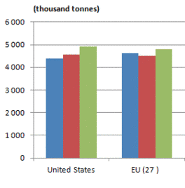Another indicator of potential market development is to analyse the recent trends of banana imports in Chiquita’s primary markets. Figure 1.7 indicates a steady increase in the amount of bananas imported into the US and EU markets over the last three years. This would indicate a healthy demand for Chiquita's banana product in the short term and possible opportunities for growth.

Banana prices may also be an indicator of market development. As seen in Figure 1.8, the price in both markets rose until the recession of 2008. The EU market has seen a slight decrease in prices over recent years. Banana prices steadily increased in the US market from 2008 to 2012. From 2012 to 2014 there was a slight reduction in price, which could indicate decreased profit margins for Chiquita in both these markets. This could encourage the firm to explore emerging markets, such as Asia, for new revenue streams.

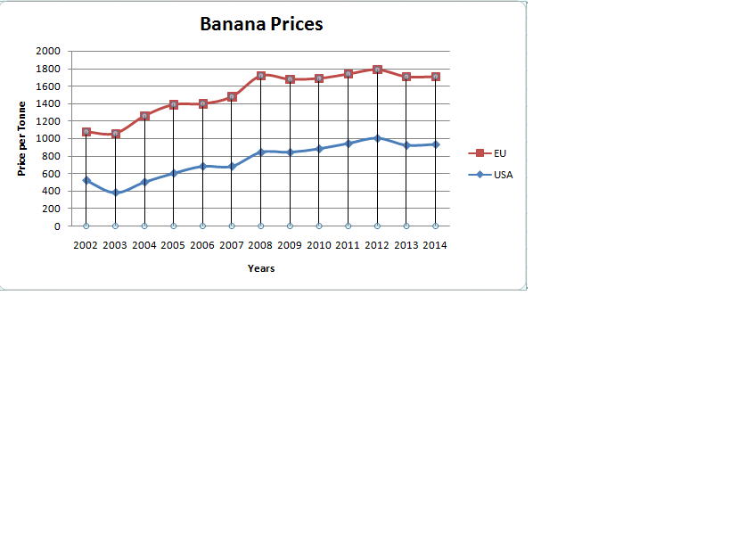

Figure 1.8

Price and quality are the basis for competition amongst most banana producers. Chiquita emphasises that it bases much of its competitiveness on quality. More than half of consumers agree that Chiquita bananas taste better than the next leading banana brand (Chiquita, 2014).

**Strategic Operations**

According to UNCTAD (2011), the primary costs for Chiquita are production and labour within its plantations and transportation, which include shipping products to target markets. Other key costs include the storage and distribution of the product to the market. Costs are incurred through foreign currency exchange within the EU and US markets. These costs have been evolving and will more than likely continue to do so.

As seen in Figure 1.9, labour costs are low, but are likely to increase with the introduction of wage regulations and workers’ rights to join trade unions.

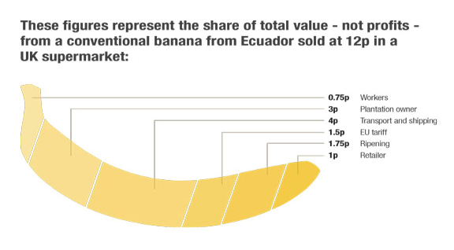

Figure 1.9

(Bananalink, 2014)

Fuel costs are likely to rise with the dwindling supply of global oil reserves. With the recent improvement in technology, other storage alternatives may become available which may help reduce these costs.

In order to reduce the risk associated with trading in foreign currency, the company could implement specialised financial engineering tools.

Chiquita's major customers are the retailers and wholesalers in the US and EU markets, and the communities that they serve. Because of the increase in low cost supermarket chains eg: Lidl, Aldi, there has been increased competition within the retail environment. Retailers such as Tesco are looking to cut cost through direct supply from banana producers and this could have a domino effect on the price Chiquita receives for its bananas.

Because bananas are necessity products, Chiquita is not overly reliant on aggressive advertising and marketing campaigns and instead mainly focuses on brand recognition. This is achieved through the trademark sticker, which denotes quality. Chiquita mainly operates through stable fixed term contracts to retailers.

The influence of modern lifestyles are now contributing to customer behaviour. Obesity is rising within America and Europe and because of this, fresh, healthy foods industries may be in jeopardy, as consumers opt for convenience foods. Older generations in Chiquita’s consumer markets are generally quite conservative in their food choice (Buckley et al., 2005). They, along with families are more concerned about their health, but if convenience foods are compatible with their lifestyle, they may find themselves straying from the traditional healthy foods (EU Report, 2010).

Sales are influenced by the production cost of bananas. The price Chiquita can charge for their banana depends on their bargaining power to negotiate their contracts with the companies that sell and market Chiquita’s bananas to consumers. While price is important to Chiquita when it comes to maintaining and increasing its business with wholesalers and retailers down the supply chain, demand would remain consistent regardless of a slight increase or decrease in price. As bananas are a necessity rather than a luxury good, like bread and milk, they are more inelastic than beef, which falls into a higher end luxury food category.

All fruit can be classified as substitutes to the banana, but nothing compares to the banana in terms of texture, taste or vitamin content. This means that it does not have any perfect substitutes, as a banana is a banana. Cereals could be regarded as a complimentary product but are subjective to individual preference.

**Opportunities**

One opportunity for Chiquita is emerging markets. Faced with fierce competition in the US and EU markets, Chiquita should respond by paying greater attention to expanding distribution networks into emerging markets. Chiquita should focus on investing in logistics rather than production to increase their geographical reach. The removal of trade barriers into these emerging markets will help accommodate this transition. Chiquita should also prioritise achieving operational savings and improving the efficiency of distribution in order to maximise the potential of these markets (FAO, 2014).

Another opportunity of Chiquita’s relates to their recent takeover by the Cutrale-Safra Group. As Cutrale operate a major orange produce operation, this would signify intent on their part to diversify into the banana sector. Chiquita has the opportunity to diversify into the orange industry, and 'access Cutrale-Safra's substantial experience in all aspects of the fruit and juice value chain and extensive financial expertise and this will help ensure Chiquita has the premier and most sustainable platform in its sector' (Reuters, 2014). By diversifying into the orange market, it will allow Chiquita to expand their operations and partially eliminate the risks associated with their declining market share in the banana industry.

**Challenges**

A major challenge, not unique to Chiquita, is the threat of disease. The banana market is susceptible to natural plagues, such as the Panama disease tropical race 4 (TR4) which struck the banana plant this year, causing banana prices to skyrocket in shops by 16%. This uncontrollable factor will influence Chiquita greatly, increasing product price as supply decreases. (The Independent, 2014). The ability of disease and plague to affect Chiquita's bananas will shape their future operations, as Chiquita must attempt to counteract this threat by investing in R&D to devise new technology to protect their bananas.

The most important challenge facing Chiquita, and the banana industry as a whole, is the threat posed by the growing market share of retailers in the banana market. This drastic shift is clear as 'In 2013, the market share of the top five companies was 44.4%, down from 70% in 2002'. This is demonstrated in Figure 1.1 above where the 'Others' category at 56% is representative of the position of the major supermarket chains in the US and EU banana market. The retailers who control the grocery sector in major import countries, are now increasingly dominating the supply chain (Bananalink, 2014). They dominate the retail market in the main banana consuming countries and are also increasingly purchasing from smaller wholesalers or directly from growers. The establishment of new shipping lines to transport bananas has led to a shift in market power from major banana brands, such as Chiquita, to retailers (FAO, 2014). Despite this, the recent takeover of Chiquita by the Cutrale-Safra Group should help Chiquita cement their market position as the leading banana producer.

Other challenges faced by Chiquita include; Climate change, increased power of workers Trade Unions and the threat of possible mergers between rival banana firms. Following their recent takeover of Chiquita, Cutrale-Safra also face the challenge of maintaining Chiquita's leading position in the banana market, bolstering slim margins and mitigating volatile operating conditions (Reuters, 2014).

**Conclusion**

Chiquita have faced many adversities in recent years as a result of changing economic conditions. The banana industry has become more competitive and Chiquita must adapt to this changing environment in order to maintain its leading market position. This plan has analysed the company, its market and addressed the issues Chiquita will face over the next few years. After peeling back the skin of Chiquita, it is clear that challenges remain. But following their recent takeover by the Cutrale-Safra Group and the emergence of new markets, this will allow Chiquita to confront their challenges and prosper in the future.

**Reference****list**

Bananalink (2013). Available at: <http://www.bananalink.org.uk/content/companies> [Accessed 10 November 2014].

Buckley, M., Cowan, C., McCarthy M. & O'Sullivan, C. (2005). The convenience consumer and food-related lifestyles in Great Britain, *Journal of Food Products Marketing*, 11, 3-25

Chiquita (2014). Investor relations. Available at: <http://investors.chiquita.com/phoenix.zhtml?c=119836&p=irol-irhome> [Accessed 07 November 2014].

Chiquita Bananas (2014). Available at: <http://www.chiquitabananas.com/Banana-Information/find-banana-farm-map.aspx> [Accessed 10 November 2014].

Chiquita Fruit Solutions (2014). Available at: <http://www.chiquitafruitsolutions.com/Products-and-Capabilities/Capabilities.aspx> [Accessed 10 November 2014].

[Data.worldbank.org](http://data.worldbank.org/" \t "_blank), (2014). Available at:[http://data.worldbank.org/indicator/NY.GDP.MKTP.CD?order=wbapi\_data\_value\_2010%20wbapi\_data\_value%20wbapi\_data\_value-first&sort=asc](http://data.worldbank.org/indicator/NY.GDP.MKTP.CD?order=wbapi_data_value_2010%20wbapi_data_value%20wbapi_data_value-first&sort=asc" \t "_blank) [Accessed 12 Nov. 2014].

Evans, E and Ballen, F (2009). University of Florida: Banana Market. Available at: <http://edis.ifas.ufl.edu/fe901> [Accessed 05 November 2014].

EU Report (2010). Functional Foods. European Comission. Downloaded from: <ftp://ftp.cordis.europa.eu/pub/fp7/kbbe/docs/functional-foods_en.pdf>

Facweb.furman.edu, (2014). Banana 1. [online] Available at: http://facweb.furman.edu/~kpeterso/peterson/ecn22banana1.htm [Accessed 10 Nov. 2014].

Food and Agricultural Organization of United Nations (FAO) (2014). Commodity Markets. Available at: <http://www.fao.org/economic/est/est-commodities/bananas/en/> [Accessed 02 November 2014].

FoodDrink Europe (2014). Data and Trends of the European Foods Industry. Brussels: FoodDrink Europe.

Food Dive (2014). Top bananas: Looking at the other winners in the Chiquita deal. Available at: <http://www.fooddive.com/news/top-bananas-looking-at-the-other-winners-in-the-chiquita-deal/326495/> [Accessed 05 November 2014].

Forbes (2013). Chiquita No Longer Top Banana. Available at: <http://www.forbes.com/sites/zacks/2013/04/19/chiquita-no-longer-top-banana/> [Accessed 07 November 2014].

Reuters (2014). Cutrale-Safra wins takeover battle for fruit producer Chiquita. Available at: <http://www.reuters.com/article/2014/10/27/us-chiquita-brands-m-a-cutrale-safra-idUSKBN0IG16J20141027> [Accessed 10 November].

Vault (2014). [Available at: http://www.vault.com/company-profiles/agriculture-forestry/chiquita-brands-international,-inc/company-overview.aspx](Available%20at:%20http://www.vault.com/company-profiles/agriculture-forestry/chiquita-brands-international,-inc/company-overview.aspx) [Accessed 10 November 2014].

Food and Agricultural Organization of United Nations(FAO) (2014). The Changing Role of Multinational Companies in the Global Banana Trade. Available at: <http://www.fao.org/docrep/019/i3746e/i3746e.pdf> [Accessed 10 November 2014].

The Independent (2014). Bananageddon: Millions face hunger as deadly fungus Panama disease decimates global banana crop. [online] Available at: [http://www.independent.co.uk/news/world/politics/bananageddon-millions-face-hunger-as-deadly-fungus-decimates-global-banana-crop-9239464.html](http://www.independent.co.uk/news/world/politics/bananageddon-millions-face-hunger-as-deadly-fungus-decimates-global-banana-crop-9239464.html" \t "_blank) [Accessed 10 Nov. 2014]